AI-Driven Smart Occupancy Prediction

The domain of the Project: Machine Learning

COURSE NAME

G37-AI & ML

Team Mentors (and their designation):

Mr. Gaurav Patel
(ML & Data Engineer)

Team Members:

Ms. Tejaswini Galla

Period of the project

April 2026 to June 2026

Declaration
The project titled “AI-Driven Smart Occupancy Prediction” has been mentored by Mr. Gaurav Patel, organised by SURE Trust, from April 2026 to August 2026, for the benefit of the educated unemployed rural youth for gaining hands-on experience in working on industry relevant projects that would take them closer to the prospective employer. I declare that to the best of my knowledge the members of the team mentioned below, have worked on it successfully and enhanced their practical knowledge in the domain.

Team Members : Ms. G Tejaswini

Mentor’s Name : Mr. Gaurav Patel

Designation—Company Name: Celebal Technologies

Founder:
Prof. Radhakumari
Executive Director & Founder
SURE Trust

Table of contents
- Executive summary
- Introduction
- Project Objectives
- Methodology & Results
- Social / Industry relevance of the project
- Learning & Reflection
- Future Scope & Conclusion

Executive Summary
The AI-Driven Car Occupancy Prediction project aims to improve parking management by predicting whether a parking space will be occupied or vacant based on historical parking patterns, sensor data, traffic conditions, temporal information, and user-related factors. The increasing demand for parking spaces in urban areas often leads to congestion, delays, and inefficient utilization of available parking resources. This project addresses these challenges through a data-driven predictive approach.
The system utilizes a parking occupancy dataset containing sensor readings, environmental conditions, traffic information, and parking usage records. Data preprocessing, exploratory data analysis, and feature engineering techniques were applied to enhance data quality and extract meaningful insights. Several machine learning algorithms, including Logistic Regression, Random Forest, and XGBoost, were trained and evaluated to identify the most effective predictive model.
Performance evaluation demonstrated that the machine learning models achieved high predictive accuracy and strong classification performance, with XGBoost selected as the final deployment model due to its robustness and scalability. Feature importance analysis revealed that historical occupancy information, temporal patterns, and aggregated sensor features were among the most influential factors affecting parking occupancy predictions.
To enable practical usage, the trained model was deployed through a user-friendly Streamlit web application, allowing users to input parking-related parameters and receive real-time occupancy predictions. The application also provides model performance metrics and feature importance visualizations to enhance interpretability.
The project demonstrates the potential of machine learning and IIoT-based data analytics in developing intelligent parking management solutions. The proposed system can assist parking operators, urban planners, and smart city initiatives in improving parking utilization, reducing vehicle search time, and enhancing overall traffic efficiency. Future enhancements may include real-time sensor integration, mobile application support, parking reservation systems, and advanced predictive analytics for smart city environments.
Introduction

1. Background and Context of the Project
With the rapid growth of urbanization and vehicle ownership, parking management has become a significant challenge in cities, commercial complexes, educational institutions, and public facilities. Drivers often spend considerable time searching for available parking spaces, leading to traffic congestion, fuel wastage, and reduced user convenience. Traditional parking systems generally provide limited information about parking availability and lack predictive capabilities. Advances in Machine Learning and Industrial Internet of Things (IIoT) technologies have enabled the development of intelligent parking solutions that can analyze parking patterns and predict occupancy status. This project focuses on leveraging data-driven techniques to improve parking space utilization and support smarter parking management.

2. Problem Statement and Project Goals
Finding available parking spaces in busy areas is often difficult due to the absence of real-time predictive information. Existing parking systems mainly indicate current occupancy status but do not provide forecasts regarding future availability. This limitation results in inefficient parking utilization and increased vehicle search time.
The primary goal of this project is to develop a machine learning-based smart parking occupancy prediction system capable of predicting whether a parking space will be occupied or vacant using parking sensor data, temporal information, traffic conditions, and historical occupancy patterns. The project also aims to provide an interactive web-based application that enables users to obtain occupancy predictions in an easy and user-friendly manner.

3. Scope and Limitations of the Project

Scope
- Analyze parking occupancy data and identify key influencing factors.
- Perform data preprocessing, exploratory data analysis, and feature engineering.
- Train and evaluate multiple machine learning models for occupancy prediction.
- Deploy the selected model through a Streamlit-based web application.
- Provide occupancy predictions based on user-supplied parking conditions.

Limitations

- The system relies on historical dataset patterns and may not fully represent all real-world parking scenarios.
- Real-time IIoT sensor integration is not implemented in the current version.
- The dataset contains a limited number of records, which may affect generalization to larger environments.
- External factors such as special events, road closures, or unexpected traffic conditions are not considered.
- Predictions are based on available input features and may vary when operating conditions change significantly.

4. Innovation Component in the Project
The innovative aspect of this project lies in combining machine learning techniques with IIoT-inspired parking data to create an intelligent occupancy prediction system rather than a simple parking monitoring application. The project incorporates advanced feature engineering techniques such as cyclical time encoding, lag-based occupancy features, rolling occupancy averages, and sensor interaction features to improve prediction performance. Multiple machine learning models were evaluated and compared to identify the most effective solution. Furthermore, the predictive model was deployed as an interactive Streamlit web application, enabling practical usage and demonstrating how intelligent analytics can support smart parking management and future smart city initiatives.

Project Objectives
The primary objective of this project is to develop a machine learning-based smart parking occupancy prediction system capable of accurately predicting whether a parking space is occupied or vacant. The project aims to utilize parking sensor data, traffic conditions, temporal information, and historical occupancy patterns to improve parking management and resource utilization.
The specific objectives of the project are:
- To collect and analyze parking occupancy data and identify the factors influencing parking space utilization.
- To perform data preprocessing and exploratory data analysis to improve data quality and understand occupancy patterns.
- To apply feature engineering techniques for extracting meaningful information from parking data.
- To develop and compare multiple machine learning models, including Logistic Regression, Random Forest, and XGBoost, for occupancy prediction.
- To evaluate model performance using appropriate classification metrics and select the most effective model.
- To deploy the trained machine learning model through a user-friendly Streamlit web application.
- To provide real-time occupancy predictions based on user inputs and parking-related conditions.
- To demonstrate the application of Machine Learning and IIoT concepts in smart parking management systems.

Expected Outcomes and Deliverables
The expected outcomes and deliverables of this project are:

Expected Outcomes
- Accurate prediction of parking occupancy status (Occupied or Vacant).
- Improved understanding of parking utilization patterns through data analysis.
- Identification of key factors affecting parking occupancy.
- Enhanced parking management through predictive analytics.
- Demonstration of Machine Learning applications in smart city solutions.

Deliverables
- Cleaned and preprocessed parking occupancy dataset.
- Exploratory Data Analysis (EDA) reports and visualizations.
- Feature-engineered dataset for model training.
- Trained and evaluated machine learning models.
- Performance evaluation reports and comparison metrics.
- Serialized machine learning model files.
- Streamlit-based Smart Parking Occupancy Prediction web application.
- Final project documentation and presentation materials.

Methodology and Results

Methods and Technology Used
The project follows a machine learning-based approach to predict parking occupancy status using historical parking data, sensor readings, traffic information, temporal features, and user-related attributes. The methodology consists of multiple stages including data collection, data preprocessing, exploratory data analysis (EDA), feature engineering, model training, evaluation, and deployment.
The collected dataset was first cleaned and analyzed to identify patterns and relationships among features. Feature engineering techniques such as cyclical encoding, lag feature generation, rolling averages, and interaction features were applied to improve model performance. Multiple machine learning algorithms, namely Logistic Regression, Random Forest, and XGBoost, were trained and evaluated using classification performance metrics. The best-performing model was selected and deployed through a Streamlit-based web application for real-time occupancy prediction.
Tools and Software Used:

Tool / Software | Purpose
Python | Programming Language
Pandas | Data Manipulation and Analysis
NumPy | Numerical Computations
Matplotlib | Data Visualization
Scikit-learn | Machine Learning Model Development
XGBoost | Advanced Boosting Algorithm
Pickle | Model Serialization
Jupyter Notebook | Model Development and Experimentation
Streamlit | Web Application Deployment
GitHub | Version Control and Project Repository

Data Collection Approach
The project utilizes a parking occupancy dataset containing parking sensor information, environmental conditions, vehicle details, traffic levels, temporal information, and historical occupancy records. The dataset contains approximately 1000 records with multiple features representing parking conditions.
The collected data includes:
- Sensor Reading (Proximity, Pressure, Ultrasonic)
- Weather Conditions
- Traffic Level Information
- Vehicle Type Details
- User Type Information
- Parking Zone Details
- Payment Status
- Historical Occupancy Information
- Time and Date Attributes
The dataset was used for model training, testing, and validation to develop an accurate occupancy prediction system.

Project Architecture

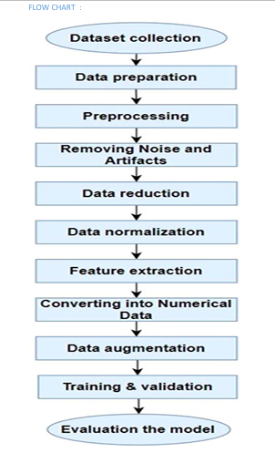

Architecture Description
The parking occupancy dataset is first processed through data cleaning and preprocessing techniques. Exploratory Data Analysis is then performed to identify trends and occupancy patterns. Feature engineering techniques generate additional predictive features such as cyclical time variables, lag occupancy features, and rolling averages. Multiple machine learning models are trained and evaluated, after which the best-performing model is selected and stored using Pickle. The trained model is integrated into a Streamlit web application where users provide parking-related inputs and receive occupancy predictions in real time.

Project Overview Page

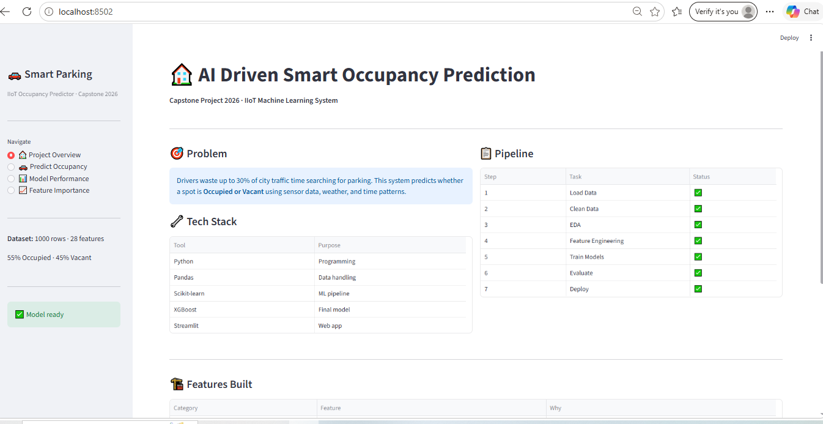
The Project Overview page introduces the AI Driven Smart Occupancy Prediction, explains the problem statement, technology stack, project workflow, and key features implemented in the project.

Occupancy Prediction Input Page
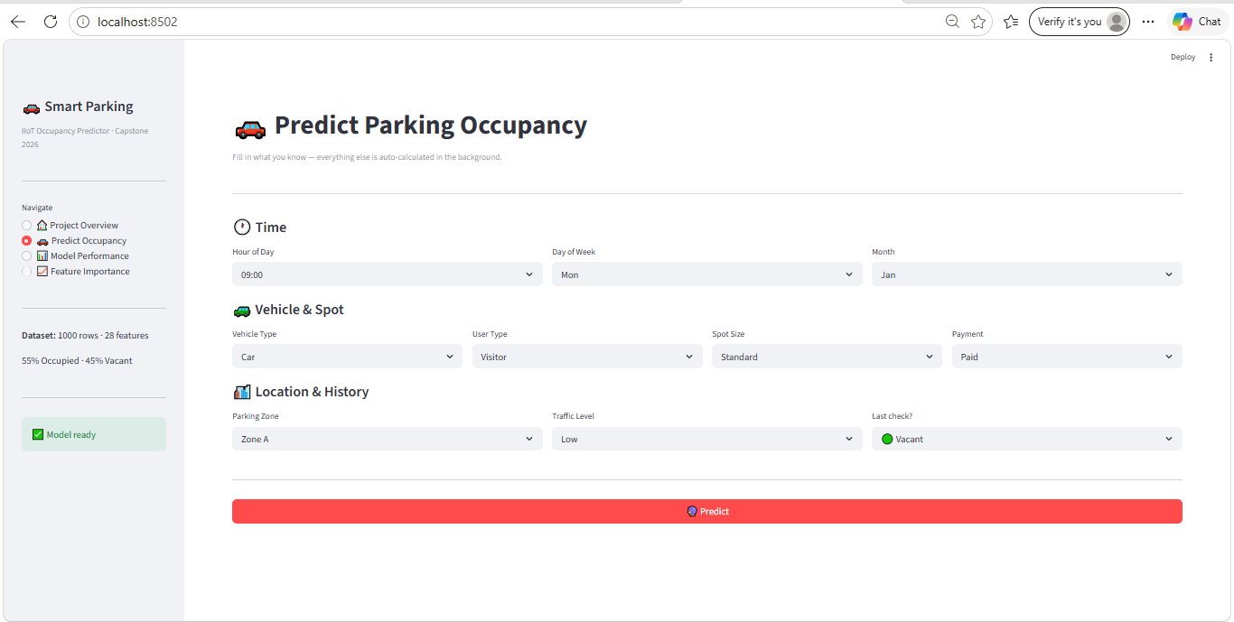
This page allows users to enter parking-related information such as time, vehicle type, parking zone, traffic level, and previous occupancy status. These inputs are processed and transformed into model-compatible features.
Occupied Prediction Result
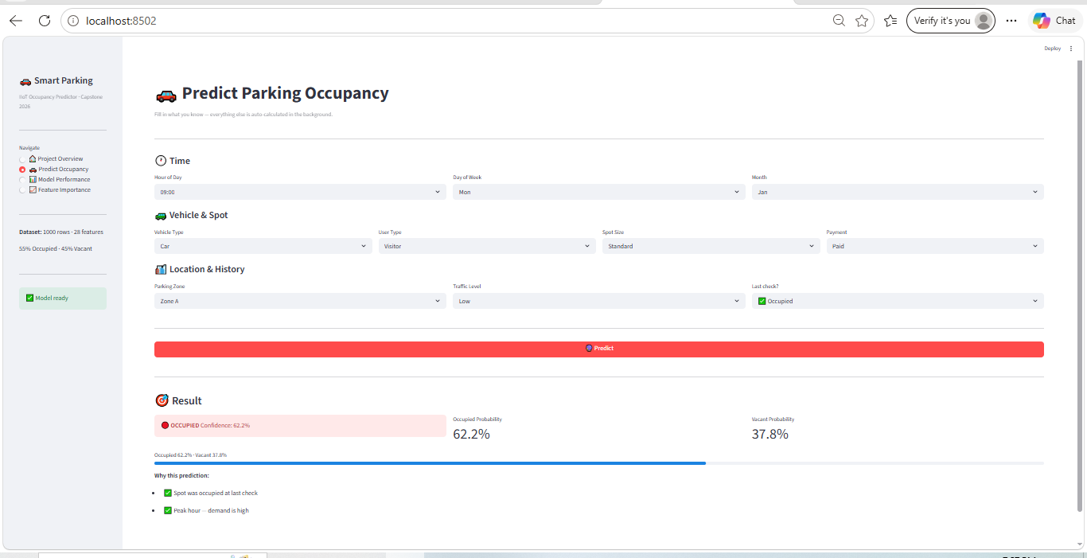
After entering the required inputs and clicking the Predict button, the system displays the predicted occupancy status along with confidence scores and occupancy probabilities.
Vacant Prediction Result
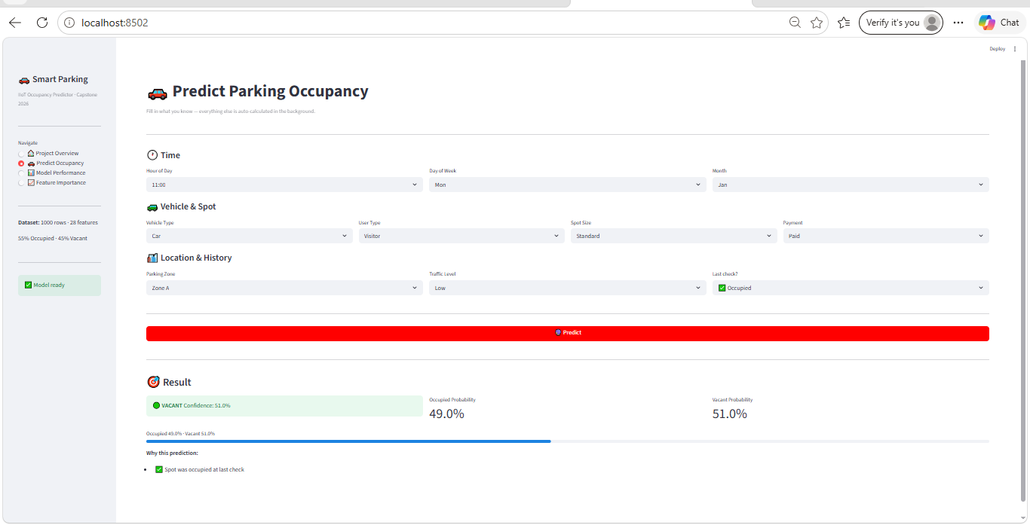
The system predicts that the selected parking space is vacant and displays the associated confidence level and probability values.
Model Performance Page
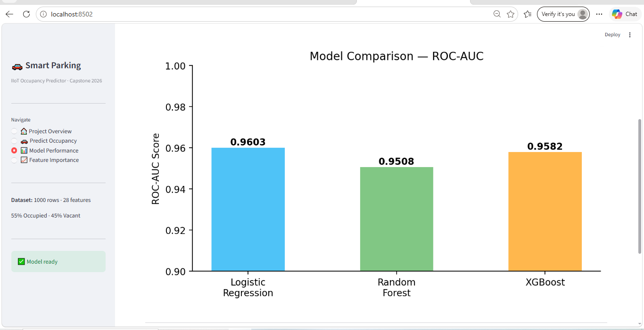
This page presents a comparison of machine learning models used in the project, including Logistic Regression, Random Forest, and XGBoost. Performance metrics such as ROC-AUC scores are displayed for model evaluation.

Feature Importance Page
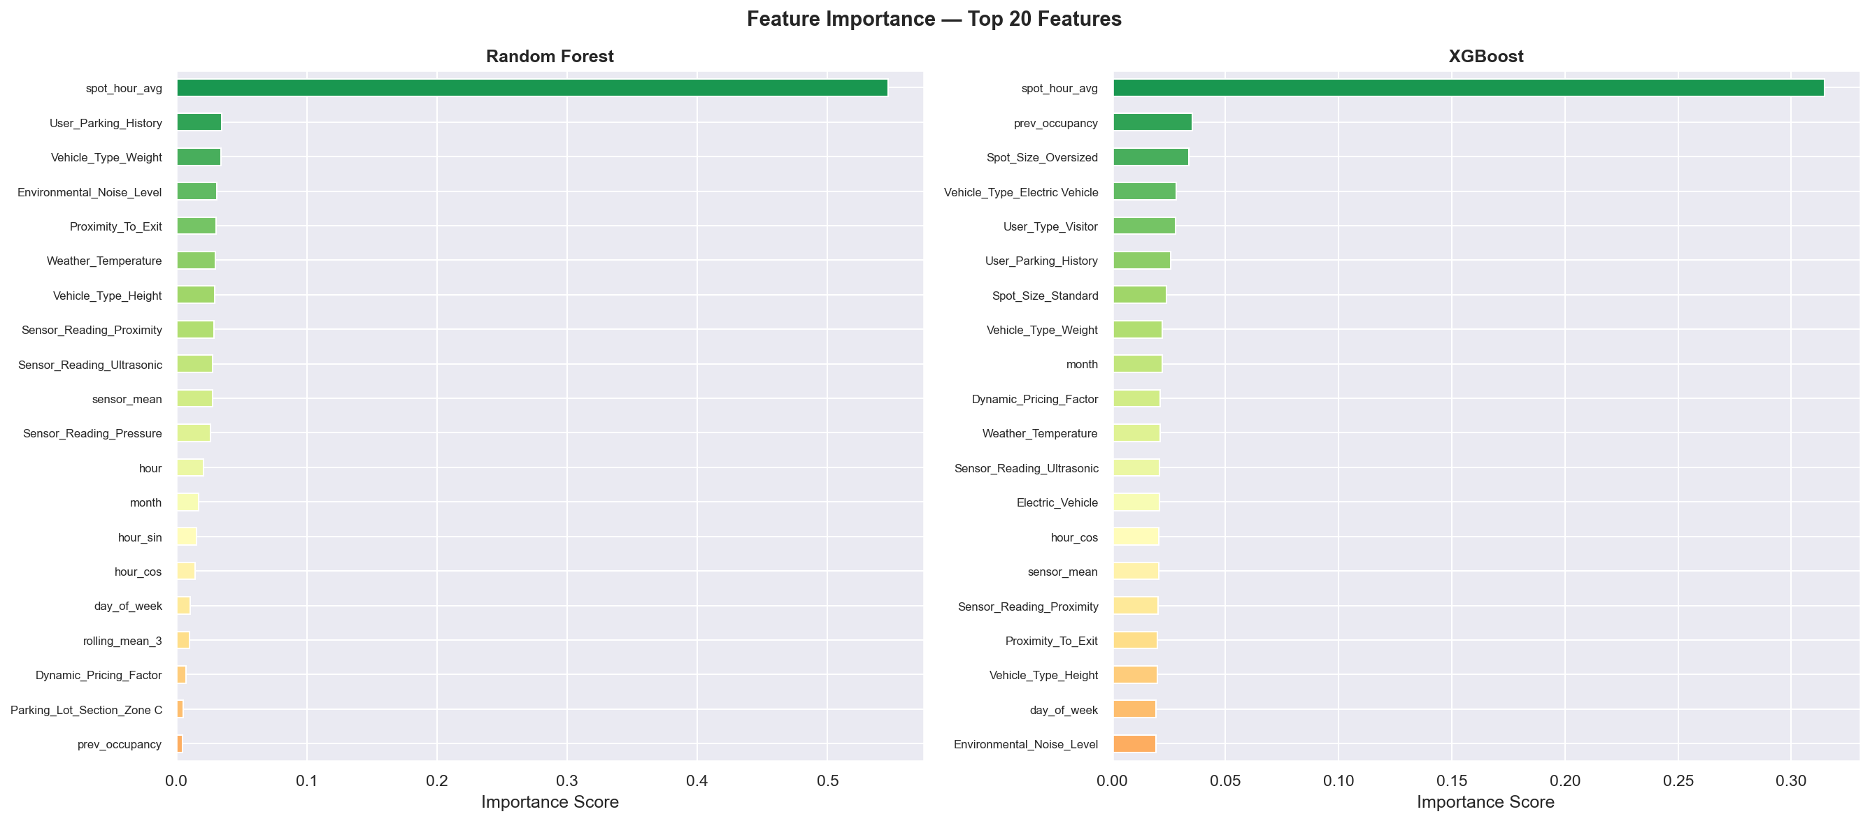
The Feature Importance page visualizes the most influential features affecting occupancy prediction. Historical occupancy, temporal features, and aggregated sensor information contribute significantly to model decisions.

Occupancy Distribution Graph

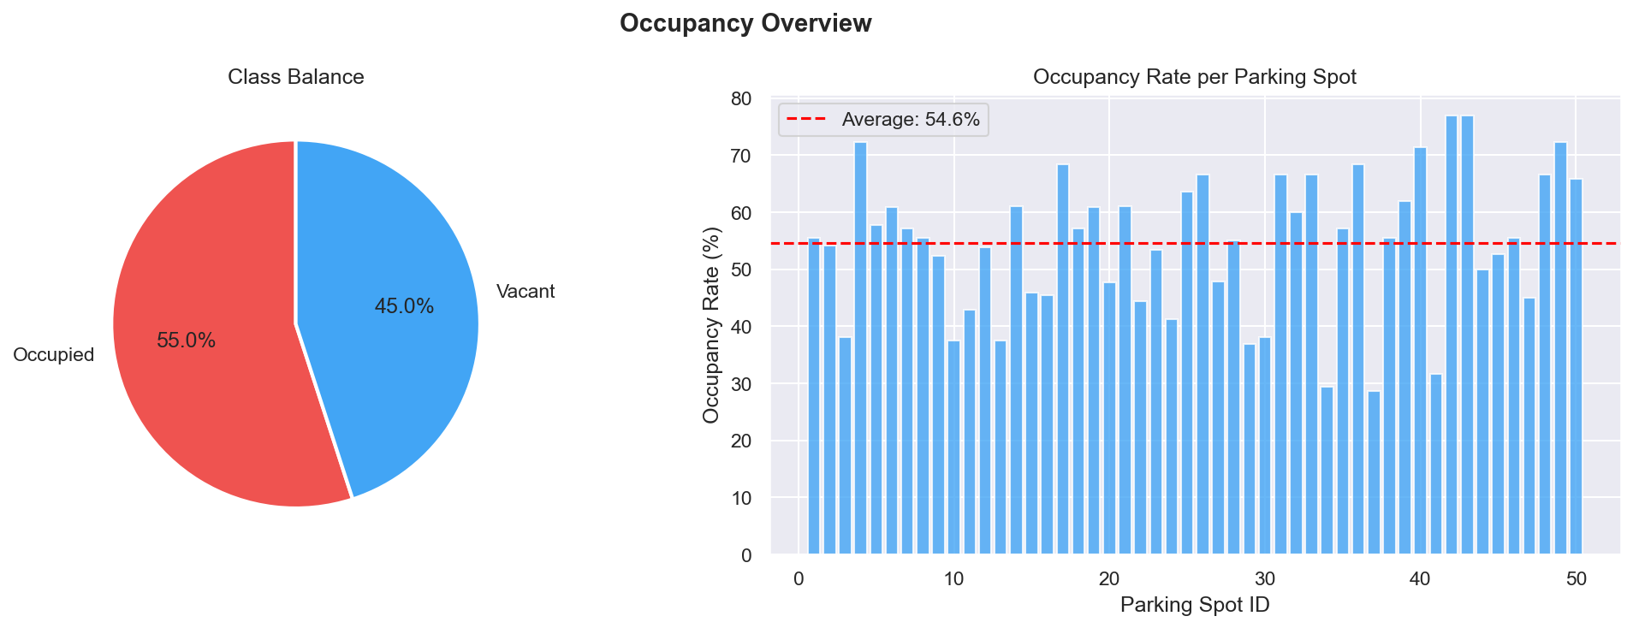
The occupancy distribution graph illustrates the proportion of occupied and vacant parking spaces in the dataset. The distribution indicates that the dataset is reasonably balanced, allowing the machine learning models to learn both classes effectively and reducing the risk of biased predictions.

Temporal Analysis Graph
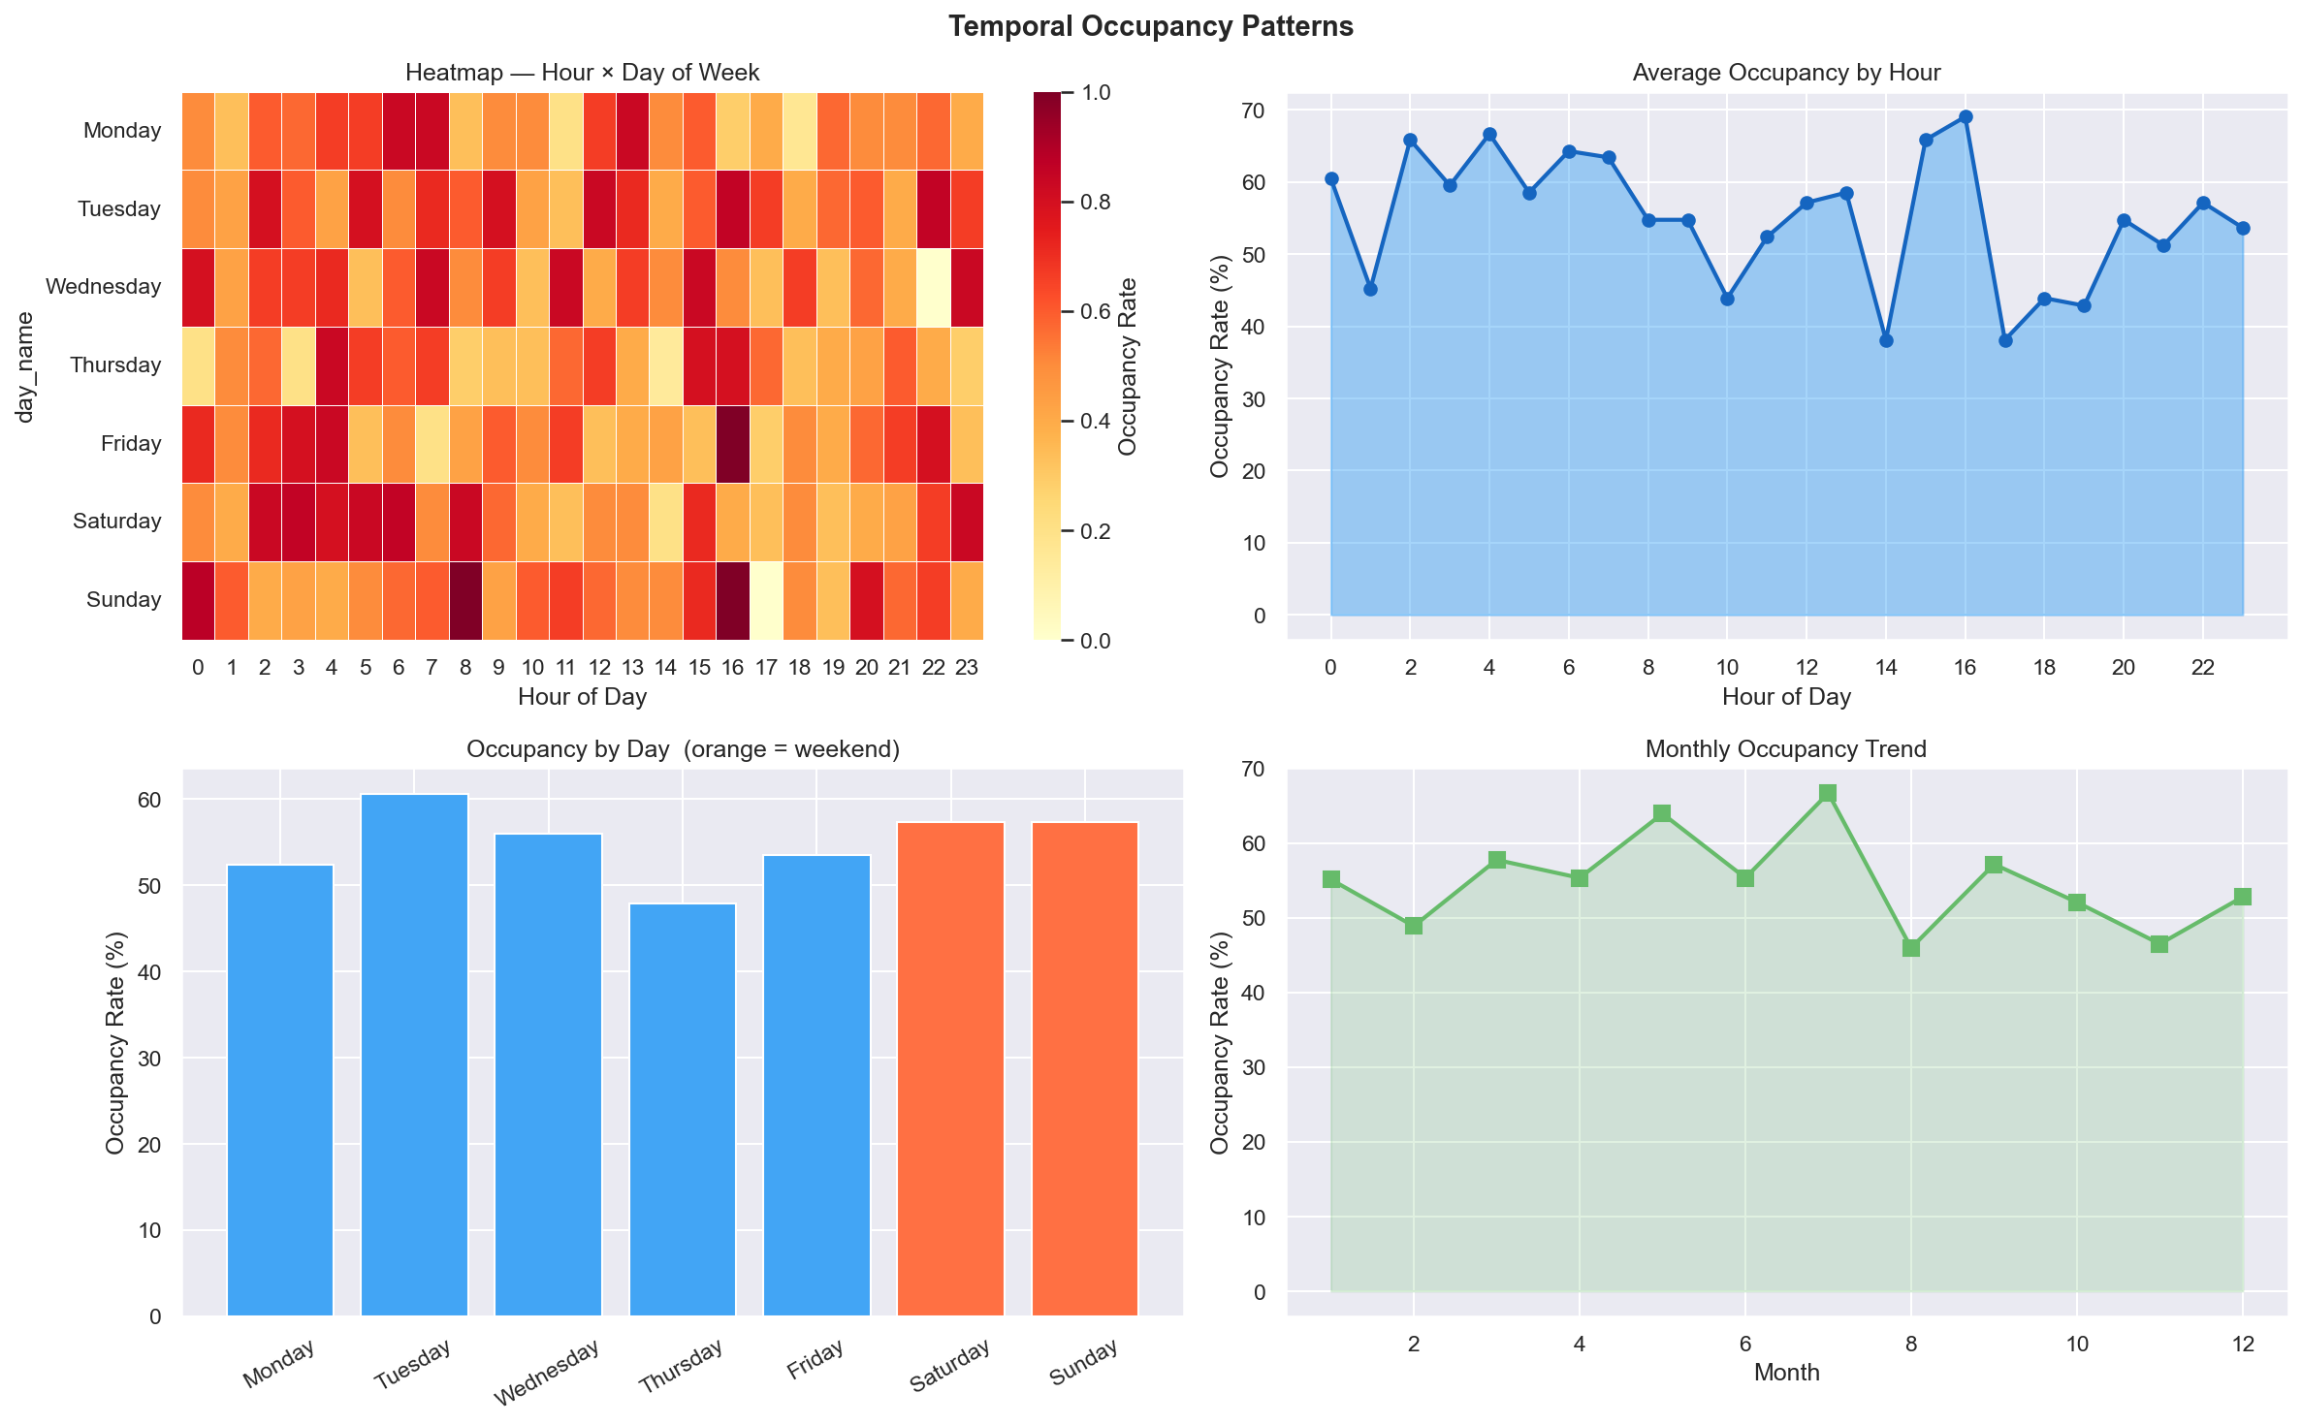
The temporal analysis graph highlights how parking occupancy varies across different time periods. Higher occupancy levels are observed during peak hours, indicating that time-related features significantly influence parking availability and are important predictors in the model.
Confusion Matrices
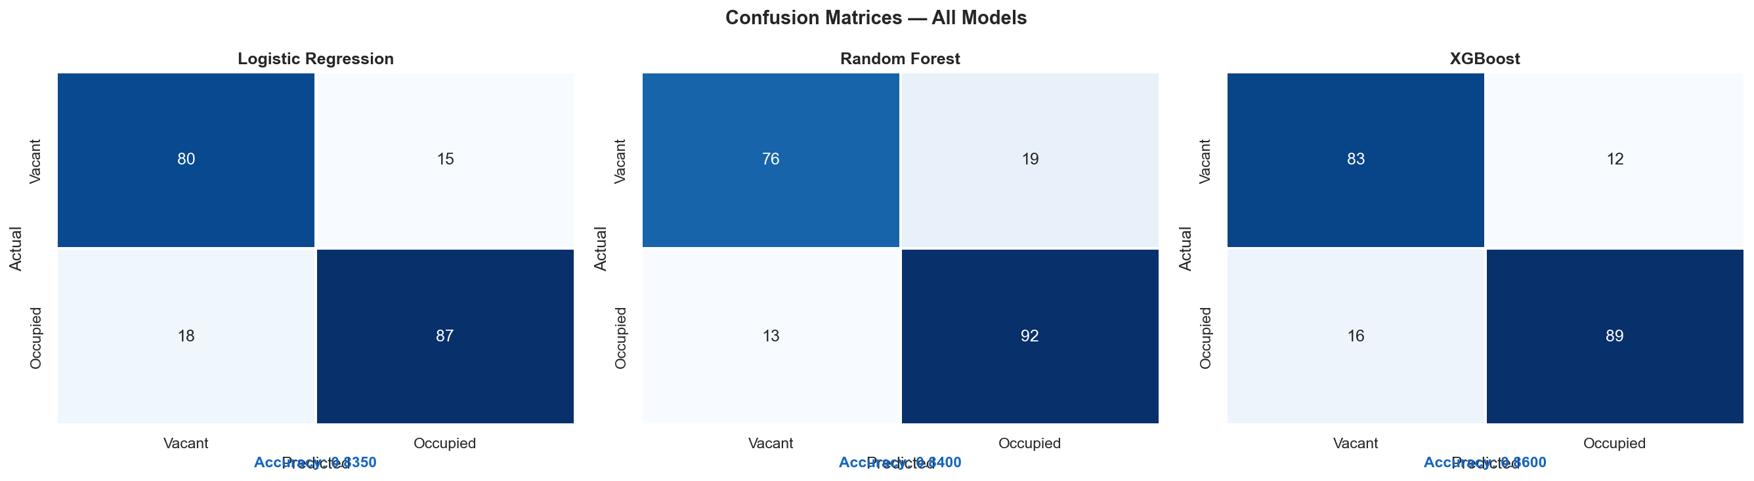
The confusion matrix evaluates the classification performance of the selected machine learning model by comparing actual occupancy values with predicted values. The matrix demonstrates the model's ability to correctly classify occupied and vacant parking spaces with high accuracy.
Correlation Matrix
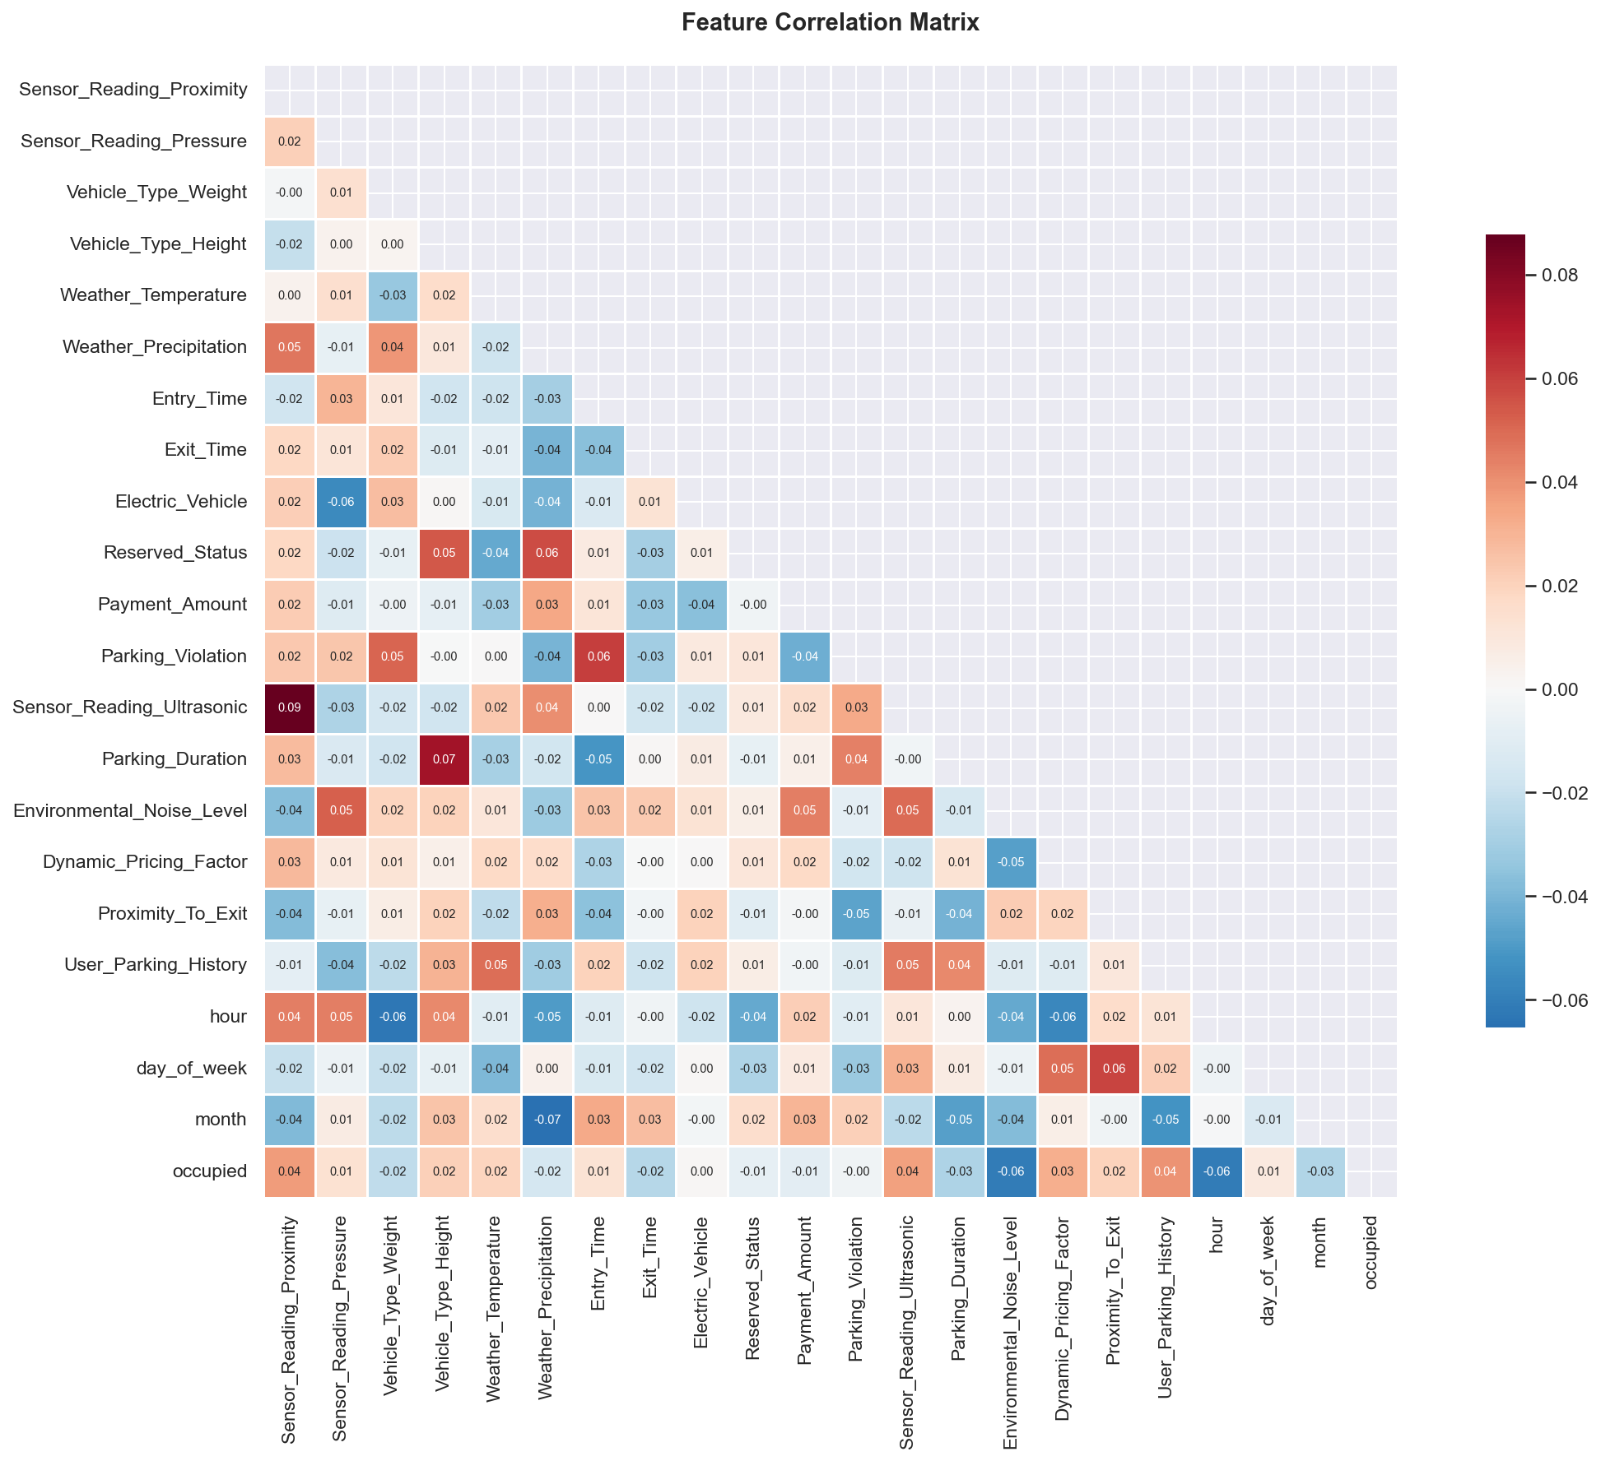
The correlation matrix visualizes the relationships among different variables in the dataset. It helps identify features that strongly influence parking occupancy and provides insights into dependencies between sensor readings, traffic conditions, and occupancy status.

Project GitHub Link
GitHub Repository:
https://github.com/sure-trust/TEJASWINI-GALLA-g37-ai-ml

Learning and Reflection
During the development of the AI Driven Smart Occupancy Prediction project, I gained practical experience in various technical and professional areas.

Technical Learnings
- Learned the complete Machine Learning project lifecycle, including data collection, preprocessing, feature engineering, model training, evaluation, and deployment.
- Improved my skills in Python programming and data analysis using Pandas and NumPy.
- Gained hands-on experience in Exploratory Data Analysis (EDA) and data visualization using Matplotlib.
- Learned how to apply feature engineering techniques such as cyclical encoding, lag features, and rolling averages to improve model performance.
- Developed an understanding of machine learning algorithms including Logistic Regression, Random Forest, and XGBoost.
- Learned how to evaluate classification models using metrics such as Accuracy, Precision, Recall, F1-Score, ROC-AUC, and Confusion Matrix.
- Acquired experience in deploying machine learning models using Streamlit and creating interactive web applications.
- Learned how to serialize and load trained models using Pickle for deployment purposes.
- Improved my understanding of Smart Parking Systems and Industrial Internet of Things (IIoT) concepts.

Professional and Management Learnings
- Improved problem-solving and analytical thinking skills while addressing project challenges.
- Learned project planning and task management throughout the development process.
- Enhanced documentation and reporting skills.
- Developed the ability to research, learn, and implement new technologies independently.

- Improved presentation and communication skills through project documentation and demonstration activities.

Overall Experience
The internship project provided valuable practical exposure to real-world machine learning application development. Working on the Smart Parking Occupancy Prediction System allowed me to apply theoretical concepts learned during academic studies to a complete end-to-end project. I gained experience in handling datasets, developing predictive models, evaluating their performance, and deploying them through a user-friendly web application.
The project helped strengthen my technical knowledge in machine learning, data analysis, and application deployment while also improving my problem-solving and project management abilities. Throughout the project, I encountered various challenges related to data preprocessing, feature engineering, model selection, and deployment, which enhanced my learning experience and confidence in developing AI and machine learning solutions.
Overall, the internship was a highly enriching experience that provided both technical and professional growth, preparing me for future opportunities in the fields of Data Science, Machine Learning, and Artificial Intelligence.

Conclusion and Future Scope
The AI Driven Smart Occupancy Prediction project was successfully developed to predict whether a parking space is occupied or vacant using historical parking data, sensor readings, traffic conditions, temporal information, and user-related attributes. The primary objective of the project was to create an intelligent parking prediction system capable of assisting in efficient parking management and improving parking space utilization.
The project involved data preprocessing, exploratory data analysis, feature engineering, model training, evaluation, and deployment. Multiple machine learning algorithms, including Logistic Regression, Random Forest, and XGBoost, were implemented and compared to identify the most effective predictive model. The selected model demonstrated strong predictive performance and was successfully integrated into a Streamlit-based web application that provides real-time occupancy predictions through an interactive user interface.
The project successfully achieved its intended objectives by developing an end-to-end machine learning solution, improving understanding of parking occupancy patterns, and demonstrating the practical application of machine learning techniques in smart parking systems. The project also provided valuable experience in data analysis, machine learning model development, and application deployment.

Future Scope
Although the developed system provides accurate parking occupancy predictions, several enhancements can be implemented in the future to improve its functionality and real-world applicability.

Future Enhancements
- Integration with real-time IIoT sensors for live parking occupancy monitoring.
- Development of a mobile application for easier user access and notifications.
- Implementation of a parking reservation and booking system.
- Integration with smart city infrastructure for large-scale parking management.
- Incorporation of real-time traffic and weather data to improve prediction accuracy.
- Expansion of the system to support multiple parking locations and larger datasets.
- Development of dynamic pricing recommendations based on parking demand.
- Addition of real-time parking availability dashboards for parking operators.
- Use of advanced machine learning and deep learning techniques for improved predictive performance.
- Integration with navigation systems to guide drivers directly to available parking spaces.
The implementation of these enhancements can transform the system into a comprehensive smart parking management solution capable of supporting modern urban mobility and smart city initiatives.

